SUMMARY
CITIZEN SCIENCE AND THE BIRD FLYWAYS IN PROTECTED AREAS OF MEDITERRANEAN EUROPE

Our project mission is to prevent early school leaving by presenting our schools’ new curricula (field trip activities, art and music groups, science workshops). Early school leaving is strongly linked to social disadvantage and low education backgrounds. Some groups in society are especially affected by it (persons with physical and mental disabilities or other special educational needs). Focusing our activities on reducing experience of school failure and growing alienation from school by targeting support for pupils to cope with emotional, social or educational difficulties, personalized and flexible learning arrangements, active forms of learning, 'learning by doing' - pupils will gain feeling of support, higher motivation, better skills, more knowledge, and stronger attachment to school which prevents early school leaving. We will increase success of the pupils with the low basic skills (pupils whose educational potential requires support) and we will bring together pupils with low basic skills, early school leavers, together with pupils with disabilities. Staff will encourage pupils' development by helping them to expand their key competencies thoroughly and will as well help pupils with low basic skills to integrate, be part of better peer-learning and peer-assessment. Peer and self-assessment are linked to many key competencies such as initiative and entrepreneurship, learning to learn and social competence, and cross-cutting themes, such as critical thinking, creativity, initiative, problem-solving, risk assessment, decision-taking, and constructive emotional management. Pupils will develop social skills, improve educational offer, provide additional support and create innovative and stimulating learning environments adapted to pupils’ specific needs. In this project we want to undertake the important mission of protecting nature, sharing citizenship and conserving endangered species, long time after our Erasmus project ends. Participants of this project will offer new curricula to the other European schools during the “school open doors events” as well as via e-Twinning.

Starting from a simple topic such as birds and parks, pupils will gain knowledge about clean water and air, migration, European countries and territories, protected areas, ancient cities, national parks, biodiversity, science, civil unions, citizenship, Youthpass, flags and heralds, English, Italian, Greek and Latin language, ICT web 2.0 and 3.0 tools, open DATA, history and cultural tradition... And besides scientific challenges they will show their unique and “childish” side while developing an animated film with professionals from the Animation Academy.

We will explore many ancient Mediterranean cities which have a long historical tradition in sharing the living space with birds (many of them for several millennia) and we will learn that humans have not always presented danger to the birds, but they also willingly or accidentally preserved some of their habitats. Sometimes they would build houses with suitable place for swifts’ nestles (Athens, Dubrovnik, Rome, Porto, Seville...) and sometimes they would accidentally help birds by building Soltworks Park (Salt evaporation ponds) like in Nin/Croatia and Ston/Croatia – probably the first documented Salt evaporation pond in Europe – founded in 1360 by Dubrovnik Republic. Pupils will build nestles for birds as well as bird feeders.

All the countries that take part in the project share rich natural heritage, unique habitats, animals and plants. Those values are recognized and preserved through the protected areas network or through the Natura 2000 network. However, there is a great responsibility behind it – European citizens have to secure favourable conservation status of all of those natural values. In developed European countries regular citizens are those who help scientists and institutions to collect data. Bird Breeding Atlases, Bird Migration Atlases and similar knowledge products are often produced with enormous effort of regular citizens who have in that way become citizen scientists. We need to educate our pupils from their youngest age (ECEC) that they can contribute to the scientific processes and make them aware of the fact that with limited directed knowledge they can help in nature conservation.

If we think of the European continent as a living organism, the flyways would be the vascular system of that being, carrying birds through the blood vessels. Three main flyways (streams) connect European scientists and now those flyways will connect young pupils under Citizen Science Erasmus project. Citizenship and environmental awareness are the main objectives of our schools and our outdoor activities. After participating in this project some pupils would become ambassadors and protectors of the birds. They will increase and share their knowledge in the future and keep on with mobility, science attachment, school attainment and education challenges long after Horizon 2020.

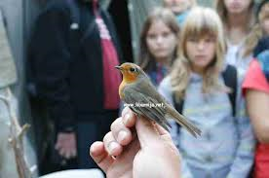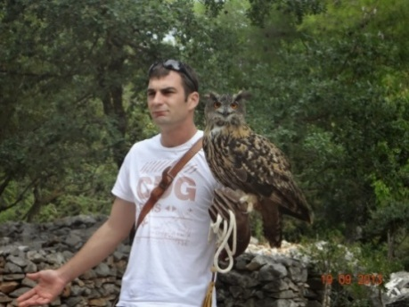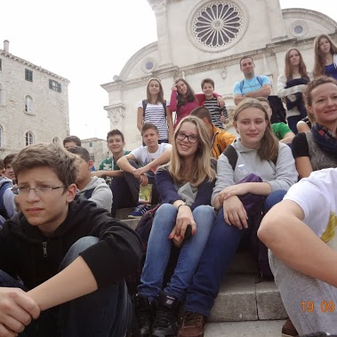
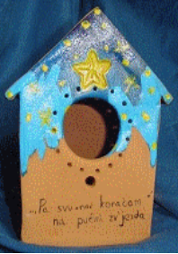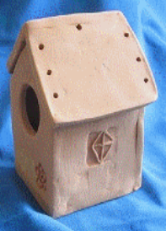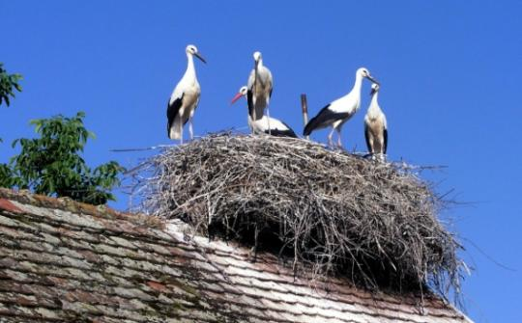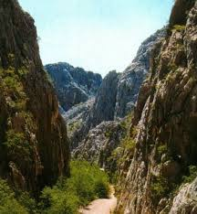

In today’s society children are often alienated, their attention is dispersive, they poorly organise their free time and the so-called “modern way of living” increases the risks of early school leaving. Being constantly exposed to different sources of unfiltered information, pupils tend to get overly distracted over time, which usually results in disheartening belief that they don't have enough time to reconcile play-time with learn-time. This project will offer them certain organisational skills, basic elements of scientific research, and provide fun time with their peers.
Our main objective is to promote the “Citizen Science” principle among youth, their families and teachers as well as to raise awareness on birds, birds migration, migration routes (flyways) in protected areas of Mediterranean Europe. Partner schools will develop programmes (curricula) which include local protected areas, three major streams among European flyways, simple conservation measures and legacy of European Citizenship. Each school will cooperate with the national BirdLife NGO local partner in order to compare migration routes and bird species that connect European countries together with different international scientific teams on the field (from the Natural Reserve of Dunes San Jacinto in Portugal, Doñana and Monfague in Spain, Plitvice and Lonjsko polje in Croatia, Parco Nazionale Gran Sasso in Italy to Gialova lagoon in Greece). Our pupils’ motto is - Today young students, tomorrow future scientists.
In this project we were carefully thinking about children needs and their sympathies towards animals, travelling, dynamic way of life, and good and positive sides of technology. We will introduce them with the representative role models (scientists, rangers, volunteers, civil activists, animated film artists, ecology union members) presented with the quality balance between social and scientific topics on one side, and games, quizzes and free time on the other side (dulce cum utile). We decided to initiate cooperation and exchanges of practices amongst elementary school and ecological associations through birds monitoring, environmental protection, field trips and non-formal learning.
Project will satisfy staff needs regarding modern and dynamic learning activities. Teachers will take part in new teaching methods advised by international colleagues, eager to amalgamate synergy between children, children parents and higher academic education, of course with the help from NGO scientific professionals. Project is based on stressing out society needs towards ecology, citizenship and scientific researches. It is obvious that all of our results and aims would not be possible to reach in a single country or by a single organisation. That is why we engaged NGO partners, scientists, faculty professors, professionals, pupils and staff from the six European schools with more than 20 volunteers.
The final goal is to create as many pupils’ presentations (scientifically orientated) together with the fundamental and representative know-how material - manual practice, new curricula proposal, brochure, blog, web site and DVD documentary. Those outcomes will ensure sustainability of the project in future and successful cooperation among citizens and pupils (Citizen Science) on advanced scientific and academic level. In our project we will include games, sport and fun; pupils will make an animated film on the birds and environment; they will enjoy quizzes, national evenings as well as workshops in different fields: ICT, arts and crafts, biology and chemistry, history, multilingual communication, civics...
The important goal of our project is to find the most effective way (using scientific, emotional and sensory approach with the sense of belonging and respect of environment) in order to merge primary and secondary school education methods with the scientific research approach, securing at the same time minimal investment costs regarding equipment and logistics.
Our aim is to explain and revitalise more than a hundred years old practice of Citizen Science in ornithology as well as to broaden our knowledge regarding protected animal and plant species, areas, reserves - protected nature - starting from micro level (School Yards and City Parks – lungs of the city) to the macro level (national protected areas – National Parks). Our further aims are to increase sensibility towards the pupils with special needs, as well as to recognise the importance of Citizenship (Euroyouth, Europass, European transparency) in theory and practice (scouts, green parties, cycling unions, and voluntary unions inside community). After each meeting coordinators will search for the improvements which will be discussed and evaluated at the staff transnational meetings.

